**Background**

Electricity consumption is one of the most common problems worldwide, many articles and blogs mention that energy consumption is always rising and which could also lead to an even bigger issue such as pollution, resource wastage like coals and natural gas which if we use would mean it will be gone forever once used. Countries who rely on coal and natural gas would be more at risk when it comes down to pollution in the environment. Energy consumption could also lead to higher demand which would mean that the cost of electricity bills would be even more expensive. The energy consumption can be reduced significantly if people learn not to waste electricity unnecessarily, nowadays children, teenagers, and even adults do not use electricity wisely, while adults may not waste as much as childrens and teenagers when compared, they are still part of a problem.

**Current situation:**

While children may not be the only causes of energy consumption, we think that they are the most critical because teenagers and adults have the ability to understand and be aware of how wasting electricity unnecessarily can lead to some consequences whereas children would not even realize the outcome of it. In today’s society many children take electricity for granted, parents have to continusly tell their children to turn off devices or any other electronics in the household and the message does not reach the children or is not as effective as it could be. The opportunity arises to help children understand the concept of saving electricity in forms of entertainment. Entertainment methods can be more effective and attractive for the children if we want them to learn valuable lesson/concept. This brings us to our proposal which is developing a mobile application game for children.

Our proposal & purpose

Since entertainment is a great source of learning, we decided to come up with an idea to develop an android game to teach kids the concept of saving electricity. The game would need to be interactive and educational for children. The game will have many levels with different scenarios that challenge children while also reflecting the real life situation.

Scope:

Measurable organisational Value:

Our project will impact on mainly two areas:

1. Social
2. Financial

Social:

The game will bring awareness to children about electricity consumption. This means that we will have encouraged and influenced children to be wiser when using electronics. This could also mean that children could not only be wise but also remind their parents about electricity and also help spread awareness to others.

Financial:

Financial impact such as electricity bill will be cheaper for parents to pay for and electricity organisations/providers will have to spend less money on expanding their business, because if we consume too much electricity not only the price of the electrivity bill will be higher, the electricity providers will also have to spend more money to expand and build more facilities for everyone.

Aim/Objectives

Our aim is to design and develop an educational android game that teaches children between 4-6 years old the concept of saving electricity.

1. Easy navigation: The children should be able to navigate easily. This means game menus and in-game interfaces should be simple to understand. Our game menu will have at most 2 buttons that the children can press. One to start the game and other to select level.
2. Conduct research on similar games: this will help us in identifying the factors that will be needed to create an educational game and also identifying where we could make improvements.
3. Audio & Visual implementations: The game will rely heavily on visuals and audio. We will need to make sure that we create scenarios with attractive visuals for children and also audio to help communicate with the children which is more effective than texts.
4. Implement Simple Interface: Our game should not have too many interfaces as it will complicate things for children. We will only implement a progression bar which determines how close you are to completing a level and the other would be a fail attempt interface such as 3 strikes and you are out and would have to restart the level.
5. Different levels: Different levels will be used to create different scenarios and challenges for children to overcome. The levels should somewhat reflect real life situations but in a form of a game.
6. Interact able objects – The children will have the ability to interact with objects during the level. This will be needed because since our game will be more like a quiz game, it will require children to choose objects which will determine whether its correct or incorrect.

Stakeholders – who will it, impact?

Our game will have an impact on 5 main stake holders, they are:

Children: children will be influenced by the game and will be aware of the electricity consumption and how to use it wisely.

Parents: Parents will benefit from this game, which means they won’t have to keep telling their children to turn off an electronic/device. This will also benefit the parents when it comes to electricity bills if their children are influenced by our game.

Electricity organisations: For electricity organisations it means they will have to spend less on operational costs but it also means they will make less money from families with wiser children.

Schools:

Government:

Research Question:

Can our educational game influence/teach children the concept of saving electricity?

This means will our game have an impact on the children? Will it impact electricity bills for parents? And will it help children making decisions when it comes to electricity consumption such as knowing when to turn off the lights etc.

Software Methodology: SDLC Spiral Model

Spiral Model is a type of iterative development style with an emphasis on risk analysis. This Model has 4 phases and for game development it will follow these phases: <https://www.tutorialspoint.com/sdlc/sdlc_spiral_model.htm>

1. Design: In this phase we have to get all the requirements needed.
2. Implement: in this phase we will implement the design phase we decided.
3. Playtest: Then for playtest we can make sure and see if what we did works and is fun for the player.
4. Evaluation: we will evaluate what we done right and what we did wrong then we will try to improve it by going back to the design phase.

Why Spiral model?

Spiral model is very flexible especially when it comes to game development. We will need to implement many functionality into our game and playtesting will be a big factor and that is why we think spiral model is the best. Spiral model is also known to be commonly used in game development. Also because we have the incremental development style, we can add more things such as levels and additional features even when the game is released or published. This model also provides with other benefits such as quick prototyping, keeping risks low, and allowing changes quickly. <http://gamedevelopertips.com/spiral-model-for-game-development/>

Spiral Model Diagram: <http://gamedevelopertips.com/spiral-model-for-game-development/>

.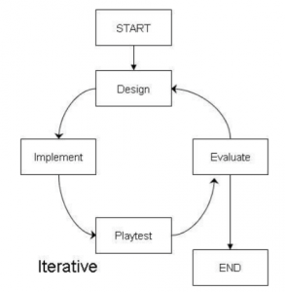

How we will use this Model?

Our first task is to make a basic design of main menu in the game, the main menu will have a Title of game, background Image, Logo or electricity based image, play button and exit button. The Main menu will be in portrait mode as well so after all that we need to implement all those design and then play test it. During play test we will check to see if our play button starts the first level as intended and if exit button closes the game app as intended. After the play test of the main menu we will then evaluate everything in that menu and see if we can make improvements to it, whether it’s better art style, image or maybe another button in the main menu.

The second task would be to design level one with all the objects we need. We will then implement the objects to be clickable or touchable and it should animate when touched/clicked on. We will then test out all the objects in the level, making sure that clicking all objects will play an animation (which is used to give feedback to the player that the object has been touched or clicked) and then lastly we will evaluate it. During evaluation we will check how we could make the animation better when clicking on objects and we could even add extra effects to our animations for a more appealing interaction with the object.

Third task will be to design and implement an icon on the top left corner to go back to the main menu. When we implement it the player should be taken back to the main menu of the game. We will test several times by going from main menu to in game and then from the in game level to the main menu by pressing the home menu icon on the top left corner of the screen. We will evaluate this implementation and see if we can make it better with help of animations or things like loading screen etc.

Fourth task will be to implement an audio voice at the start of the level, this audio will be used to communicate the objective of the level, for example when the level starts, there will be a voice explaining the scenario like “It is a bright and sunny day, mum and dad left for work and gave us the job to turn off all the electronics that are wasting power. Can you find what is wasting power?” and so a voice assistant like this will be used in the beginning of every level. After the implementation we test the game at least 3 times from menu to starting the game and check if the audio plays at the beginning of the level. After testing we will evaluate the audio, whether it is a good structured dialogue for kids with a nice friendly tone and if it needs an improvement we will implement it again with the improvements.

Fifth task is to design and implement a progress bar, the progress bar will be used when the player selects the correct object, and if it’s a correct object the progress bar will keep on filling till its maxed. We will then test it by selecting each object, correct objects should fill the bar a bit and incorrect objects should not affect the progress bar (we will use failure interface for the incorrect objects). After testing it 3 times at least we will then evaluate what we have so far and see where we can make improvements.

The sixth task will be to continue where we left off after the fifth task, we will now make sure that once our progress bar is full, the player should be shown a level complete screen and proceed to the next level. After designing and implementation, we will test these out by trying it at least 3 times and afterwards we will evaluate to see what we did right and what we did wrong. If we need improvements we will design and implement it again with the improvements.

Seventh task is it design and implement a simple UI for failed attempts which will be used to display a maximum of 3 crosses or X’s, if the player gets 3 X’s then the level should restart all over again. We will need to test this one out carefully as it might break the whole game, so we will test this one for at least times to see if everything is working as intended. When the player clicks an incorrect object, one X should be added to the top right corner, and if the player gets all 3 then restart the level. We will evaluate this as the last phase and see what we did right and where we could improve.

After implementing all the core functionalities mentioned from first task to seventh task, we can start designing and implementing different levels that have different scenario and challenges with the core functionalities already worked on. We can use the same functionalities from level 2 and implement in on to level 2 and other levels very easily since we have tested it all out one by one.

**Game Design & Analysis**

**Game Menu**



Since we are developing an educational game for children between age 4 to 6 years old, we thought that we should make our game menu simple but effective. Our game menu will have a title which is the only exception we will make because every game needs a title and we plan not to use any text in our game so children can’t be confused by several texts and some may not be able to read. The play and exit button will use an image instead and not a text based button. The menu will also contain a background music and art style to be more pleasing. The screen itself will be in portrait mode for the menu, we don’t think it would make much difference regardless of portrait mode or landscape mode since it is a main menu but we think that portrait mode will be a little bit more user friendly since people hold their phone as if they are using portrait mode.

**PLAY GAME – LEVEL 1**



Our main functionalities will be used when the level starts. Every level will have its own art style, scenario and objects. Beginning of the level a voice assistant will be used to communicate the objective of the game and give feedback to the player whenever they touch an object. We have the main menu icon in the top left corner which will take the player back to main menu. The fail or attempt indicator on the top right corner will keep track of player’s incorrect choices, if player gets 3 strikes on the attempts then the level will start automatically and it will be shown in form of a cross or X as it is appropriate design for fails and attempts. The lower progress bar in the bottom center will indicate the progress of a player and every time they click the correct object, the progress bar will fill bit by bit until it is maxed out which will lead to level completion and advances the player to the next level.

Each level will also have a different art and object placement. All objects will be interact-able so when the player touches the object, the object should animate as a visual feedback to let player know that object has been touched. There will be correct objects and incorrect objects based on the level and the scenario the player is presented. We will also add some sparkle or shiny effect on top of the object to indicate that these objects are interact-able, what this does is makes children attracted to the shiny or sparkle effect which will get them to touch the object and then with the help of voice feedback they will automatically discover how to play the game and what they should be doing once they have experienced playing around with it. Lastly the levels will be locked in landscape mode which is the most appropriate for our game as we will need the space for the art style and objects placed in the level.

Example 1 preview: Caption the image

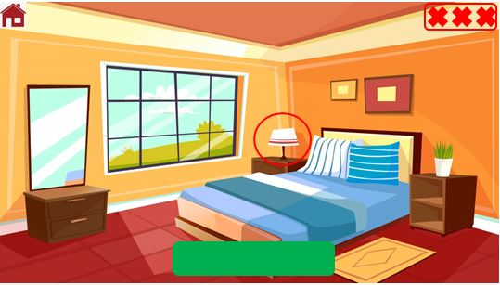

Example 2 Preview: Caption the image

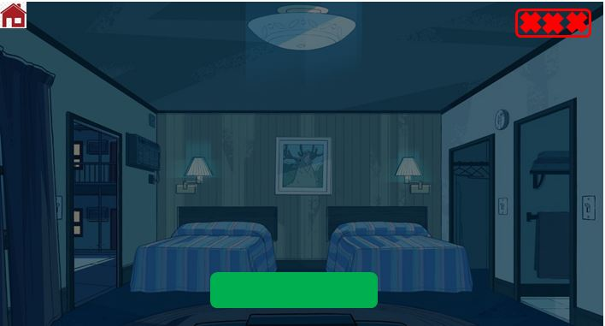

**TOUCH INTERACTION FLOWCHART**

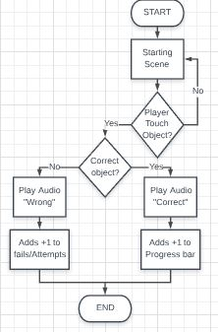

**PROGRESSING LEVEL FLOWCHART**

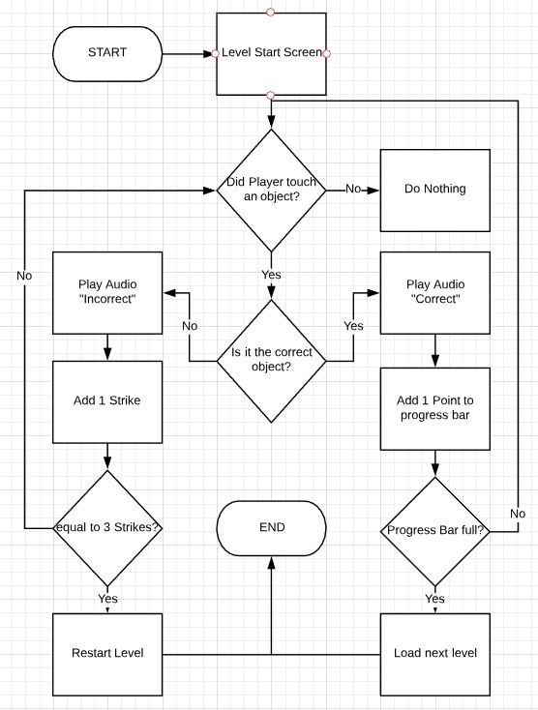

**Overview Flowchart**

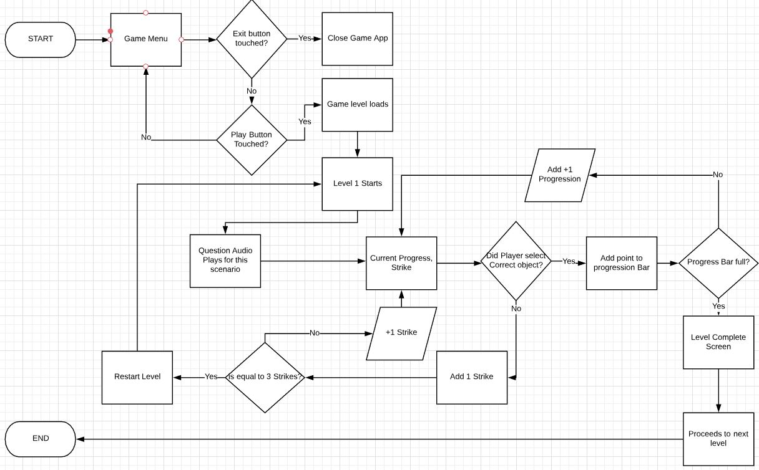

USE CASE

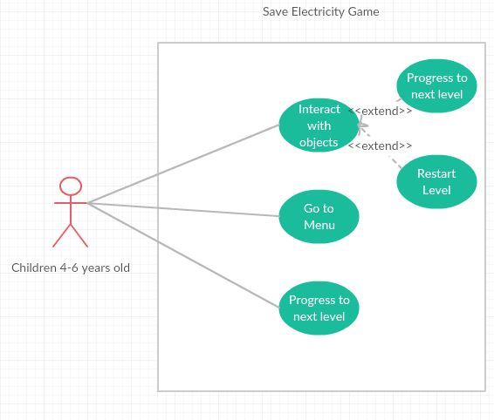

OVERALL NAVIGATION

